e. Write any two points of importance of sunlight for living things.
Ans The two points of importance of sunlight for living things are: -
1. It gives us heat and light.
2. Sunlight makes the earth warm.
f. Make a list of things that are necessary for plants to prepare their food.
Ans A list of things that are necessary for plants to prepare their food are: -
1. Sunlight 2. Water
3. Carbon dioxide 4. Minerals
g. Why are earthworms important for farmers?
Ans Earthworms are important for farmers because they make the soil fertile.
h. Write any two points of importance of air.
Ans The two points of importance of air are: -
1. Air helps in pollination.
2. Birds fly in the air.
Look at the given figure and answer the question.
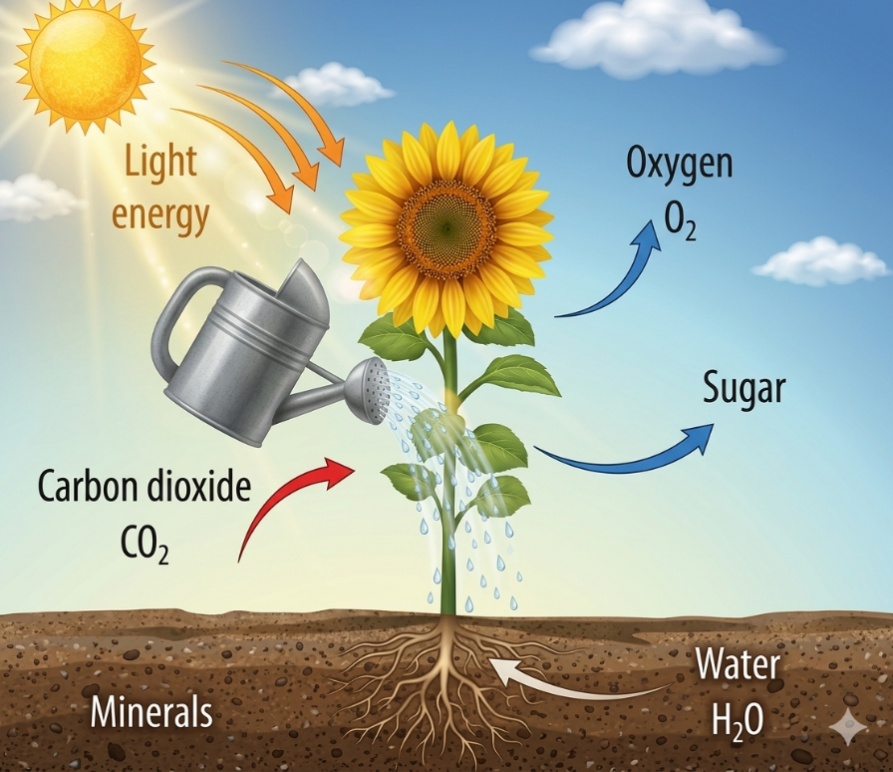

a. What is photosynthesis?
Ans Photosynthesis is the process of making food by green plants.
b. Why is photosynthesis process important?
Ans Photosynthesis process is important because it
helps plant to grow.
c. What happens to photosynthesis process if there is no sunlight?
Ans If there is no sunlight, photosynthesis process will not happen.
d. Which part of plant is involved in the process of photosynthesis?
Ans Leaf of plant is involved in the process of photosynthesis.

